PROJECT DESIGN PHASE-II

DATA FLOW DIAGRAM & USER STORIES
Date: 21 September 2026
Team ID: SWTID-2026-6999
Project Name: AI BlogNest API

1. DATA FLOW DIAGRAM

Level 0 Data Flow Diagram
The AI BlogNest API receives requests from users through a client such as Postman. The requests are processed by the backend application and pass through authentication and authorization before reaching the appropriate business modules. The system interacts with MongoDB Atlas for storing users, blogs, categories, comments, and embeddings, and with Google Gemini for AI-based blog generation and summarization. Search requests are processed through MongoDB Atlas Search and MongoDB Atlas Vector Search.

External Entities
- Admin
- Editor
- Author
- Reader

Main Processes
- User Authentication
- User and Role Management
- Blog Management
- Category Management
- Comment Management
- AI Content Generation and Summarization
- Keyword Search
- Semantic Search

Data Stores
- Users
- Blogs
- Categories
- Comments
- Embeddings

Simple Main Data Flow
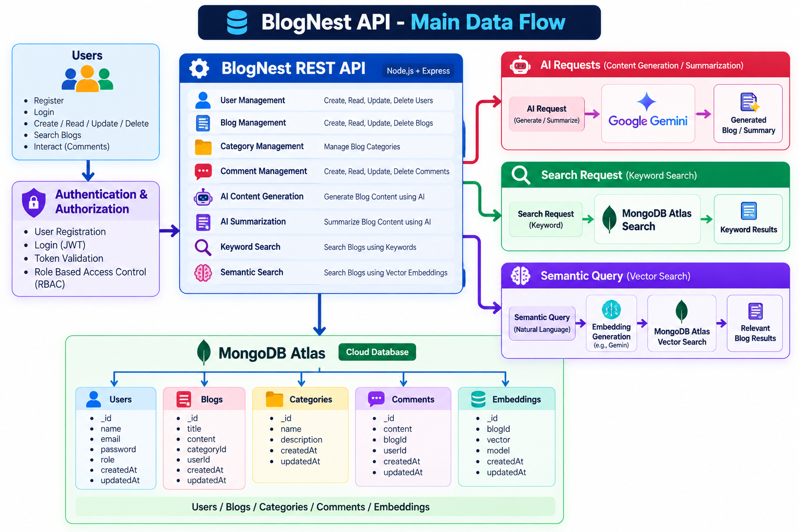

DFD (Industry Standard)
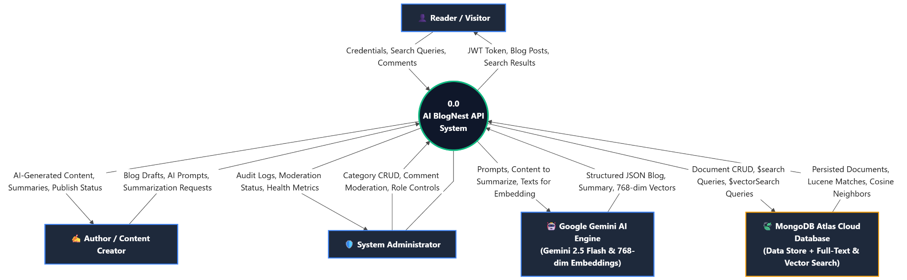

2. USER STORIES
The template requires the user type, functional requirement/epic, user story number, user story/task, acceptance criteria, priority, and release.

User Type | Functional Requirement (Epic) | User Story Number | User Story / Task | Acceptance Criteria | Priority | Release
Author | Registration | USN-1 | As an author, I can register for the application using my name, email and password. | A new account is created successfully with the default Reader role. | High | Sprint-1
All Users | Login | USN-2 | As a user, I can log into the application using my email and password. | Valid credentials generate a JWT token and allow authenticated access. | High | Sprint-1
Admin | User Management | USN-3 | As an administrator, I can view users and assign roles. | Admin can view users and change their roles to Admin, Editor, Author or Reader. | High | Sprint-1
Author | Blog Management | USN-4 | As an author, I can create a blog post. | A valid blog is created and associated with the logged-in author. | High | Sprint-2
Author | Blog Management | USN-5 | As an author, I can update and manage my own blog posts. | An author can update only posts belonging to their account. | High | Sprint-2
Editor/Admin | Publishing | USN-6 | As an editor or administrator, I can review and publish blog posts. | Authorized users can update the publishing status of eligible posts. | High | Sprint-2
Reader | Blog Access | USN-7 | As a reader, I can view published blog posts. | Published blogs are returned successfully while restricted content remains protected. | High | Sprint-2
Editor/Admin | Category Management | USN-8 | As an editor or administrator, I can create and manage blog categories. | Authorized users can create, update and delete categories according to their permissions. | Medium | Sprint-2
Reader | Comments | USN-9 | As a reader, I can add comments to published blog posts. | An authenticated reader can successfully add a comment to a published blog. | Medium | Sprint-2
Editor/Admin | Comment Moderation | USN-10 | As an editor or administrator, I can moderate blog comments. | Authorized users can change comment status such as pending, approved or spam. | Medium | Sprint-2
Author | AI Content Generation | USN-11 | As an author, I can generate blog content using AI by entering a topic. | Gemini generates structured blog content containing a title, content, summary and tags. | High | Sprint-3
Author | AI Summarization | USN-12 | As an author, I can generate a summary of blog content using AI. | The system returns a concise AI-generated summary. | High | Sprint-3
All Users | Keyword Search | USN-13 | As a user, I can search for blogs using keywords. | Relevant blogs are returned using MongoDB Atlas Search. | High | Sprint-3
All Users | Semantic Search | USN-14 | As a user, I can search for blogs using natural-language queries. | Relevant conceptually related blogs are returned using vector search. | High | Sprint-3
All Users | Secure Access | USN-15 | As a user, I can access only the features permitted for my role. | Unauthorized operations return an appropriate access-denied response. | High | Sprint-3

